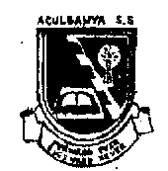

**ACULBANYA SECONDARY SCHOOL P.O. BOX 39 LIRA**

**END OF TERM ONE EXAMINATIONS 2024**

**ART AND DESIGN**

**S. 3**

**P612/1**

**STUDIO TECHNOLOGY**

**TIME: 1HRS 40 MINS.**

**INSTRUCTIONS:**

* *This paper consist of two sections A and B. it has four examination items.*
* *Answer two items choosing one from each section and stating their number.*
* *Any additional items answered will not be scored.*
* *Illustration should be put where necessary*

**SECTION A.**

**ITEM 1**

The term is ending and this is the right time that you should show to your parents that you have been practicing art and design in school.

Whenever an art work is done in colour it tends to attract every one and they admire them so much .

**Task .**

1. Through the knowledge you got from the theory about colour, let your parents to know the meaning of colour, properties of colour and different categories of colours. **(20 scores**)
2. Advise them on the different uses of colour incase they want you to continue with painting . **(10 scores)**

**ITEM 2**

A group of youth in Aboke town Council have started practicing art work and they are mainly focusing on pencil work and dealing in still life drawing as in figure 1 , fig 2 , and fig 3 , below.

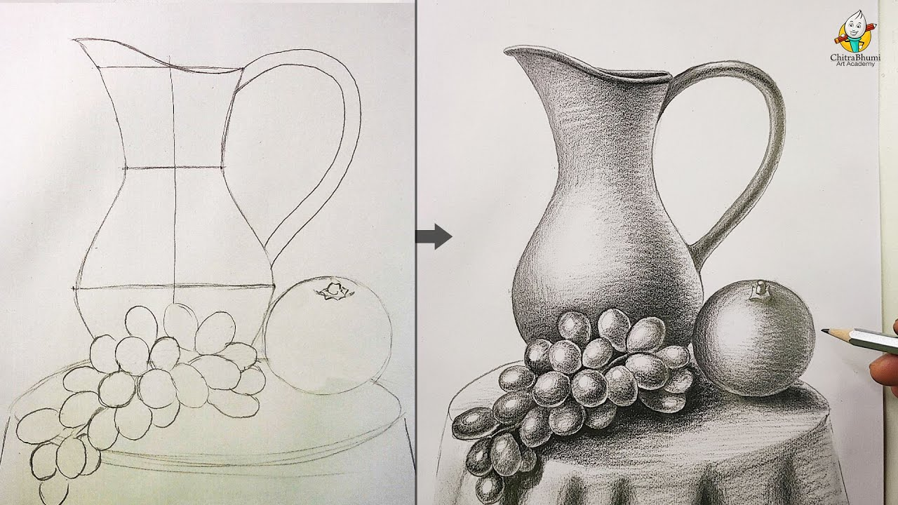**Figure 1**

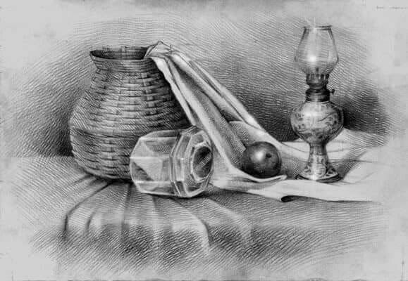**Figure 2**

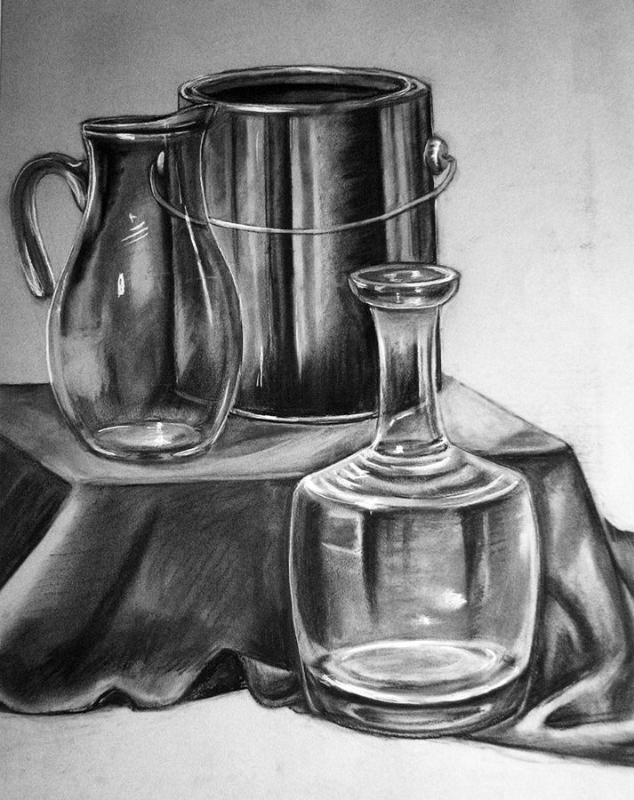

**Figure 3**

Whenever they produce drawing their art work are always admirable by people including their fellow artist from else where but they do not know the basic elements and principles of art.

**Task**

1. As a student of art design who learnt about different elements and principle of art, identify five elements and five principles of art in their art work giving a clear meaning at each**. (20 scores)**
2. Help those youth to understand the importance of these element in fig 1 , fig 2 and fig 3 . in the production of their art work. **(10 scores)**

**SECTION B**

**ITEM 3**

Good clay for pottery is good after going through its preparation process.

Johnson has a kid who likes playing with clay to make simple object’s which at times looks very interesting. Johnson would also like to prepare clay for use.

**Task**

1. Let Johnson know more on the meaning of clay and different types of clay used in pottery or ceramics. **(10 scores)**
2. Advice Johnson on the two methods used to produce ceramic and let him know different steps taken using that method. (**20 scores**)

**ITEM 4**

Community groups gather to form savings schemes commonly known as Sacco .Most of groups are set up in an informal way and therefore, have no idea of branding themselves one of the member of those groups came up with the idea of creating an identification symbols for their group and also getting for their groups uniform .

**Task .**

1. As a graphic designer, advice the group members on the qualities of good identification symbols as they plan for their design.

**(10 mark)**

1. The group chooses you to be their designer, what are some of the steps that you will take to design their identification symbol.

**(20 marks)**

**SUCCESS * END * SUCCESS**